2020

Arlo Steyn

Grade 12 E

1/4/2020

IT PAT Phase 2

[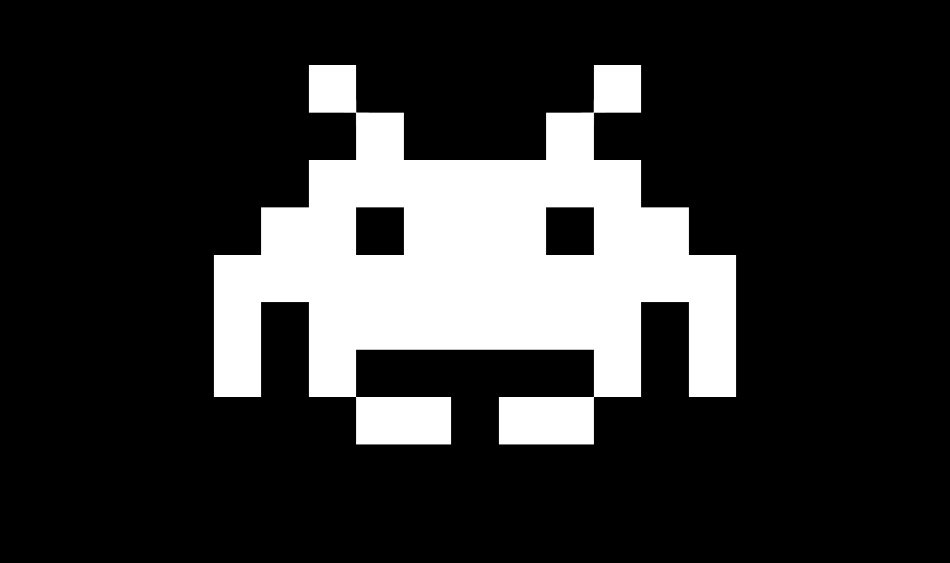](https://www.google.co.za/url?sa=i&url=https%3A%2F%2Fwww.destructoid.com%2Ftaito-and-degica-are-teasing-a-space-invaders-game-for-steam-478638.phtml&psig=AOvVaw3mkJjJR1h6JInQ3mTSj5hv&ust=1586792050925000&source=images&cd=vfe&ved=0CAIQjRxqFwoTCKCsqvCb4-gCFQAAAAAdAAAAABAL)

Space Attack

PAT Phase 2

System Design Document

**Table of Content**

User Interface Design……………………………………………………………………..2

Sequencing…………………………………………………………………………………8

Class Design……………………………………………………………………………….11

Persistent Storage Design…………………………………………….………………….17

[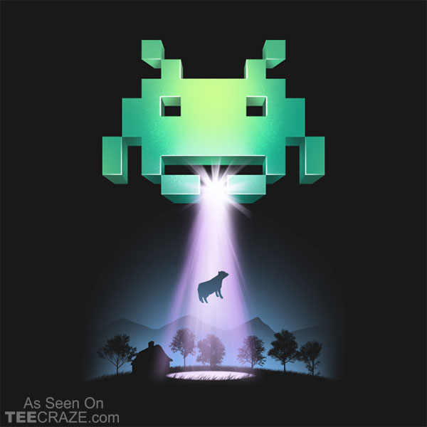](https://www.google.co.za/url?sa=i&url=https%3A%2F%2Fteecraze.com%2Fdesign%2Fspace-invaders-t-shirt%2F&psig=AOvVaw3mkJjJR1h6JInQ3mTSj5hv&ust=1586792050925000&source=images&cd=vfe&ved=0CAIQjRxqFwoTCKCsqvCb4-gCFQAAAAAdAAAAABAV)Explanation of Storage Design…………………………………………………… ……..20

**User Interface Design**

TheUser Interface Design or Graphical User Interface (GUI) will contain the following screens below. These screens will be made for the benefit of the user due to its visually appeasing, simplistic and effective design. Each of these screens will have various functions that will allow for the flow of the program.

The Welcome Screen.

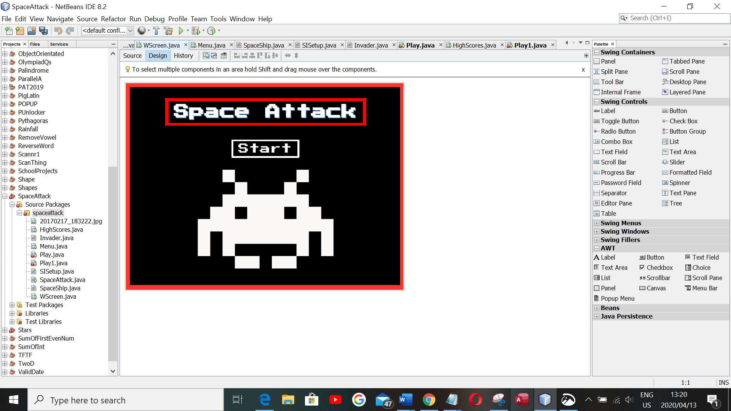

The “Start” button will allow the user to go to the menu screen when pressed.

The welcome screen will appear when the program is launched. A playlist of music will also play as soon as the program is launched. This music can be toggled on/off in the options screen.

The Menu Screen.

The “Play” button will allow the user to go to the Tutorial screen when pressed.

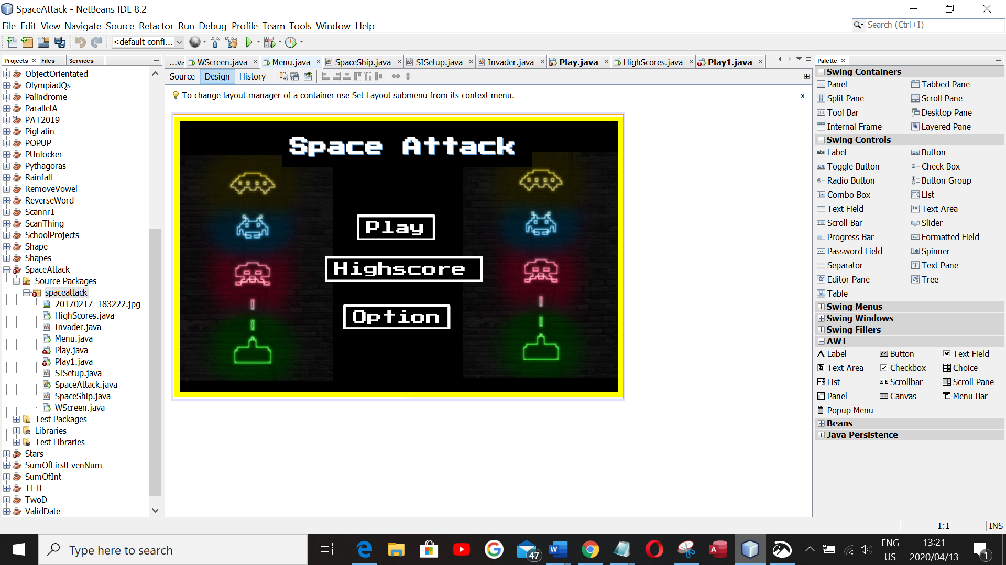

The “Highscore” button will allow the user to go to the Highscore screen when pressed.

**Highscores:**

The “Option” button will allow the user to go to the Options screen when pressed.

The Menu Screen gives the user various options. The user can either play the game, check on the high scores or select the options button if they need help.

The “Tutorial” Screen.

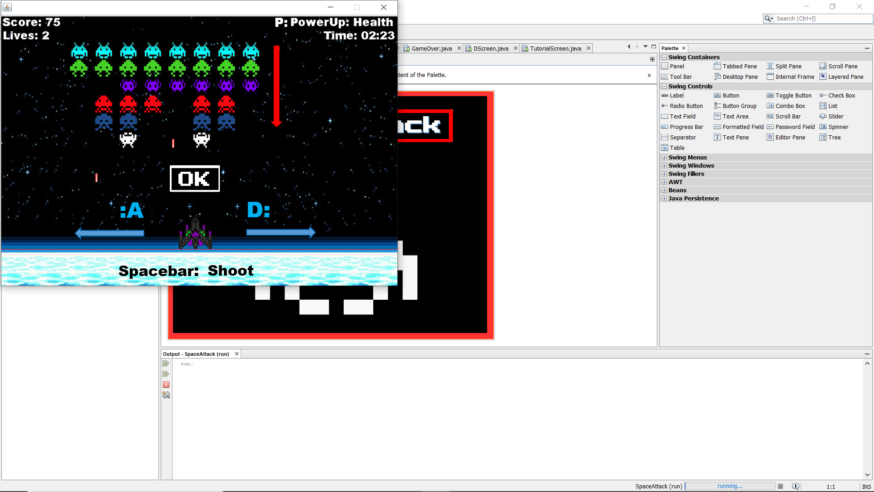

The “Ok” button takes the user to the “Play” screen.

The “Tutorial” screen is a screen shown after the “Play” button is pressed in the “Menu” screen. This screen is meant to assist the user before they enter the game by showing the functionality of the game.

The “Play” Screen.

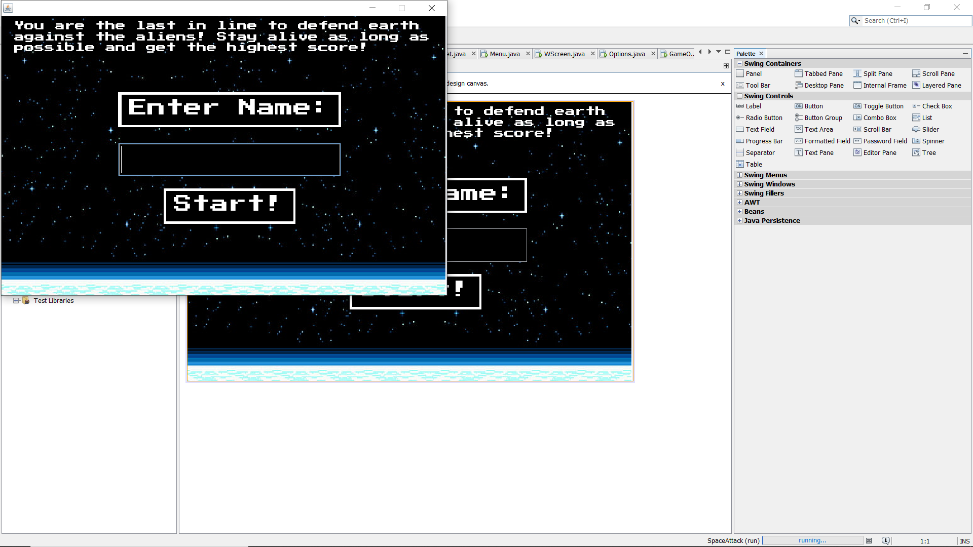

Text telling the user the goal of the game; to get the highest score and to survive as long as possible

Text Field for the user to write their name/gamer name.

The “Start!” button allows the user to start the game only if their name is valid (Less than 14 characters or more than 1 characters)

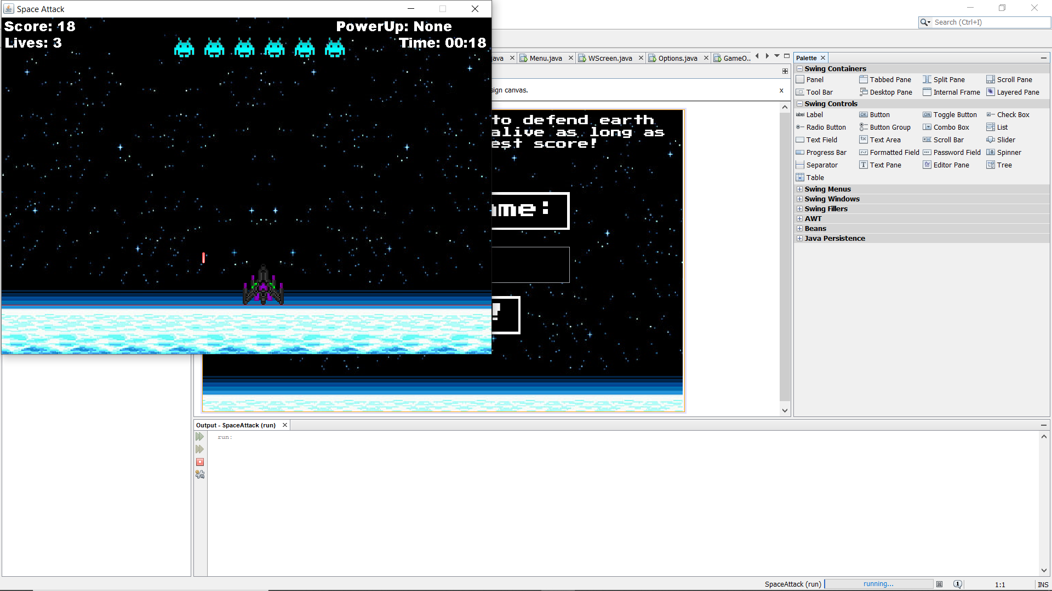The “Play” Screen

D

C

B

E

A

In this screen the user will be able to play the game. The user will be able to write their name before the game is started. This data will be used along with the timer and score value to determine a high score. This data will be given to the user once he/she has finished/died in the game. This data will also be stored in the “Highscores” screen below. The user will control the ship at **A**. The ship can move left (A key), right (D Key) and shoot bullets (Space key) to kill the aliens.

The sprites/aliens at **B** will be AI controlled. This AI/algorithm will produce more aliens as the game progresses. As the user clears the current waves, depending on the algorithm, more columns or rows of aliens will be added. Each row of alien will be a different type of alien (Image). These aliens will also move closer to the bottom of the screen until they reach the floor. These aliens will also be able to shoot back at the user until he/she has died. It is the user’s job to destroy all the aliens and get their highest scores possible.

The score and timer at **C** and **D** respectively, is displayed. Score is earned when the user destroys aliens. Score is also earned the longer the user survives.

Power Ups at **D** will be given to the user at set intervals during the game (Every 30 seconds). These power ups will be random and unique. Power ups such as, extra health, increased bullet speed, A wave clear, immunity, movement speed and added bullets will be given to assist the user as the game gets progressively harder. Some powerups are permanent (Speed, BulletVel, Health) , others periodic (AddBullets, immunity) and one expendable powerup (ClearWave).

Score is calculated by the following: Every second passed will be added to score (1:1 score and time ratio), for every alien shot, 5 score points will be given.

Lives: The user starts off with 3 lives, if the aliens hit the player with a bullet, the user loses 1 life. If the user reaches 0 lives, the game ends. At **E**, is the “Kill line”. If the aliens reach this line, the game ends. The health powerup gives 2 health points when used.

The High Score Screen.

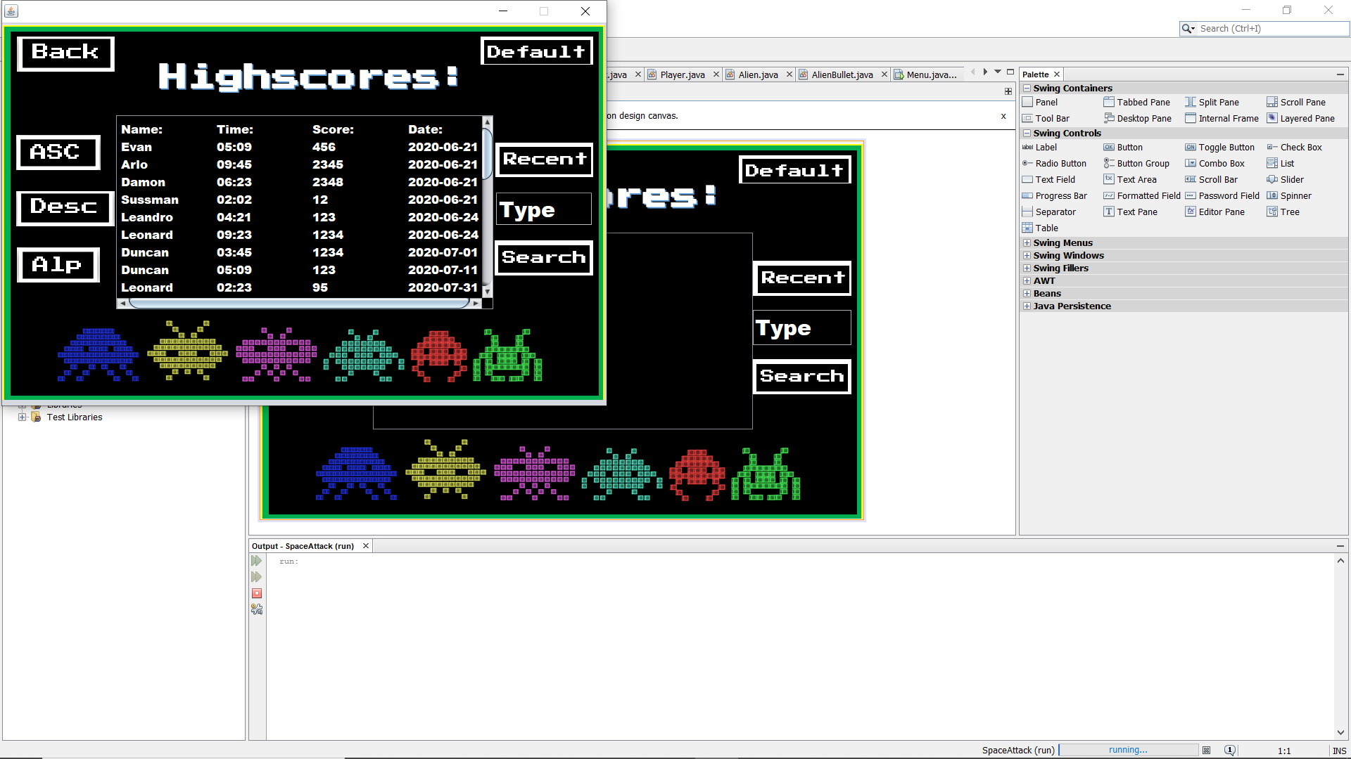

B

A

C

G

D

F

E

HG

The “Highscores” screen is shown once the “Highscores” button is pressed in the “Menu” screen. This screen shows all the user data per game played. This data is collected from a database that keeps all the data. The data kept in JTable **F** the various Names, Time (survived), Score (Final) and date played. The JTable **F** allows the user to scroll up and down to access the various data.

The “Back” button at **A** allows the user to go back to the “Menu Screen”.

The “Default” button at **B** allows the user to sort the data as it has been written in the database. (Naturally this data is sorted according the date written in ascending order).

The “ASC” button at **C** allows the user to see the data sorted in ascending order according to score.

The “Desc” button at **D** allows the user to see the data sorted in descending order according to score.

The “Alp” button at **E** allows the user to see the data sorted in alphabetical order according to Name.

The “Recent” button at **G** allows the user to see the data sorted to the most recent players played, sorted according to date.

At **H** there is a Text Field and a “Search” button. The user can search for names based on what he/she types in the text field. (Type in text field and press the search button).

The Options Screen.

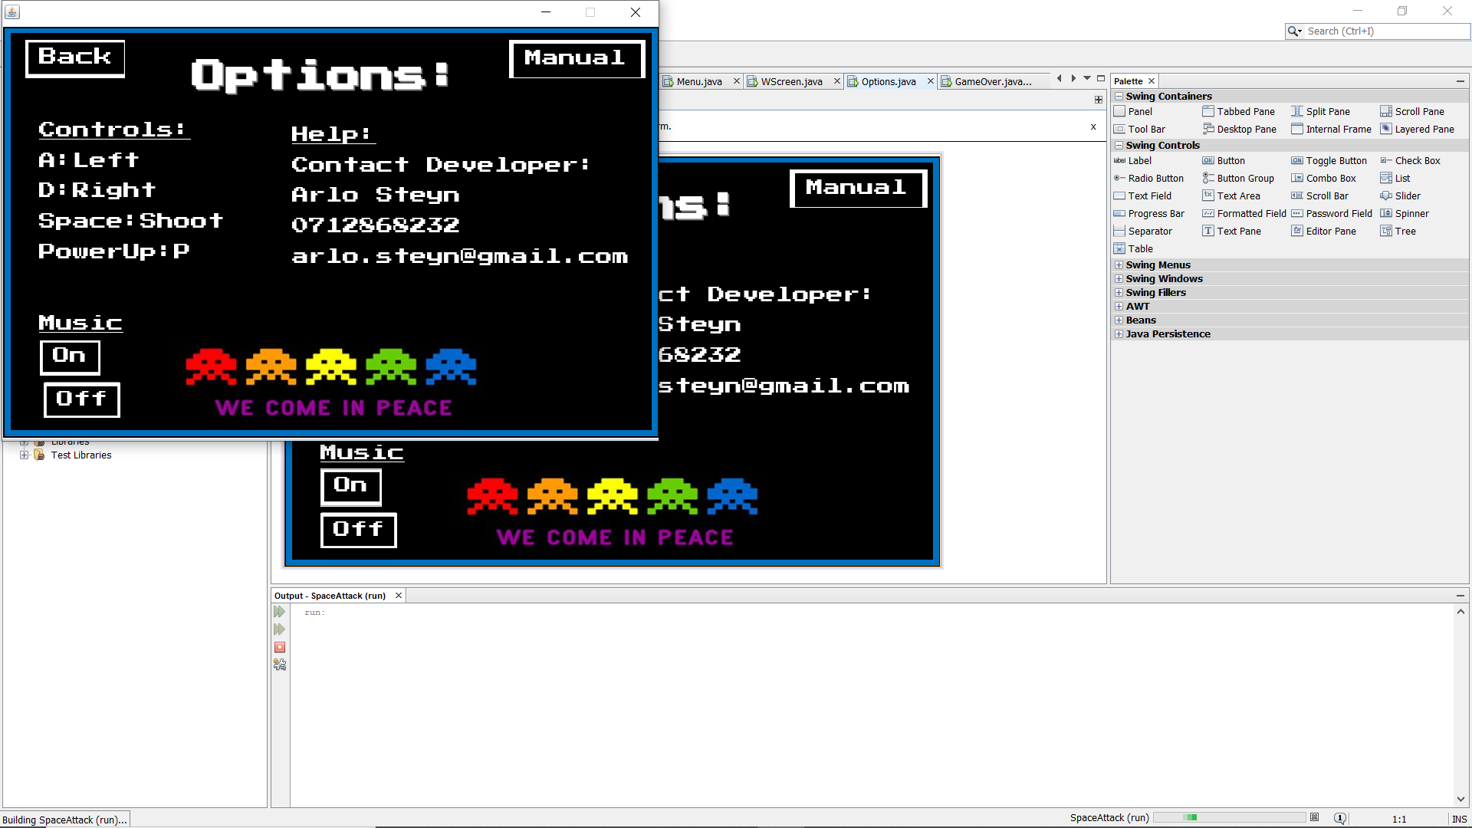

B

A

D

C

E

F

The “Options” screen can be accessed when the “Options” button is pressed in the “Menu” screen. This screen gives the user basic controls of the game and information about the developer.

The “Back” button at **A** allows the user to go back to the “Menu” screen.

The “Manual” button at **B** allows the user to go to the “Manual” screen.

The “Controls” Information at **C** shows the various controls of the game.

The “Help” Information at **D** shows the various details of the developer.

The “On” (**E**) and “Off” (**F**) buttons allows the user to toggle the music being played.

The “Manual” screen.

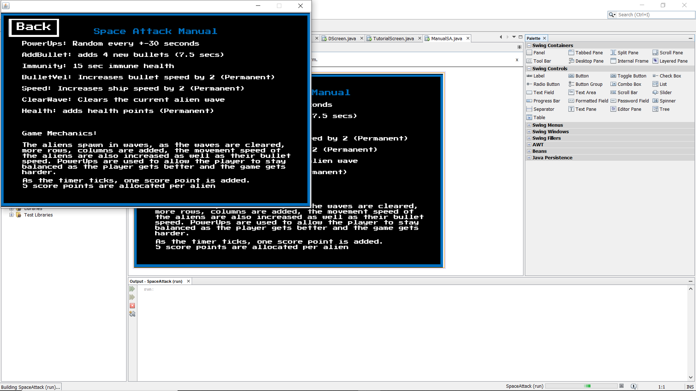

The “Back” button takes the user back to the “Options” screen.

The “Manual” screen is accessed once the “Manual” button is pressed in the “Options” screen. This screen displays powerup and game mechanics information.

The “Game Over” screen.

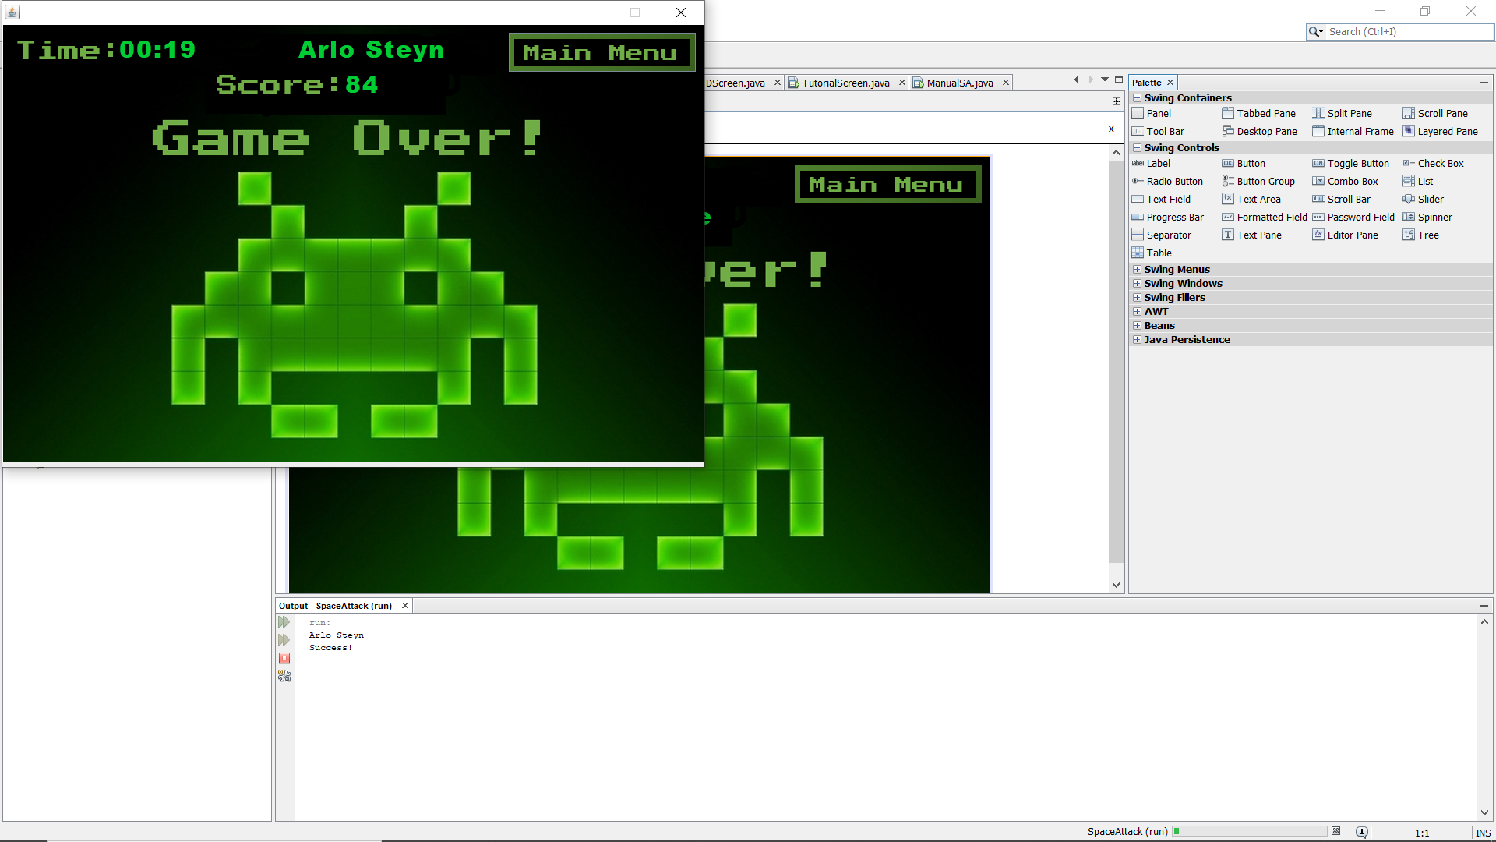

B

D

C

A

The “Game Over” screen is displayed once the user dies/game ends. Here data such as time survived, name and final score is displayed. This data as well as the current date is written to a text file to be recorded.

Time survived at **A** is recorded and displayed.

Name of the user at **B** is recorded and displayed.

Final score at **C** is recorded and displayed.

The “Main Menu” button at **D** takes the user back to the “Menu” screen.

The “Space Attack” game consists of 9 different screens. Each screen was designed in Microsoft word and implemented using snipping tool.

Visuals such as the alien sprites, bullets and player ship was gotten on the internet.

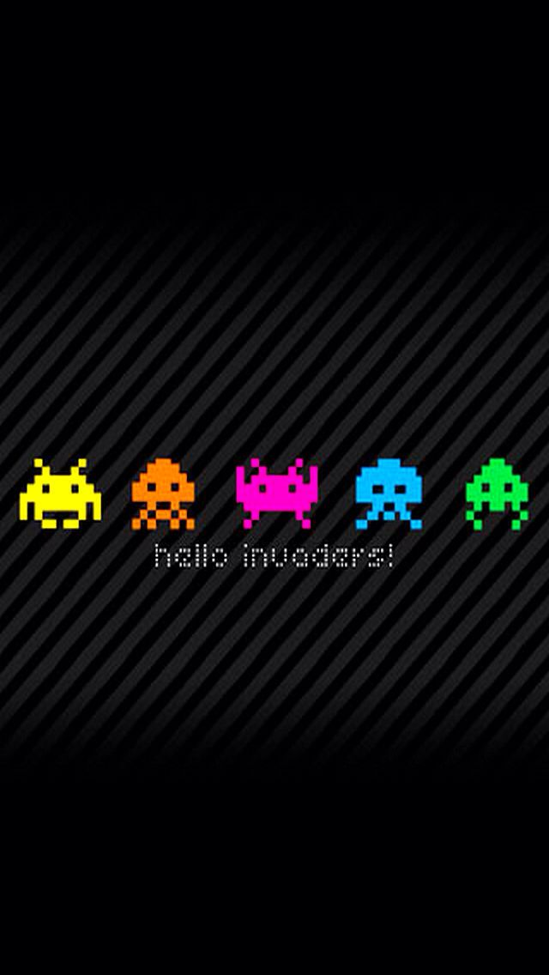

**Sequencing**

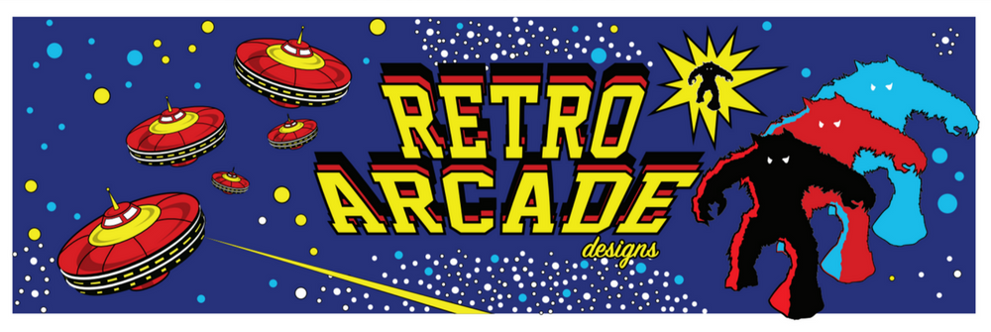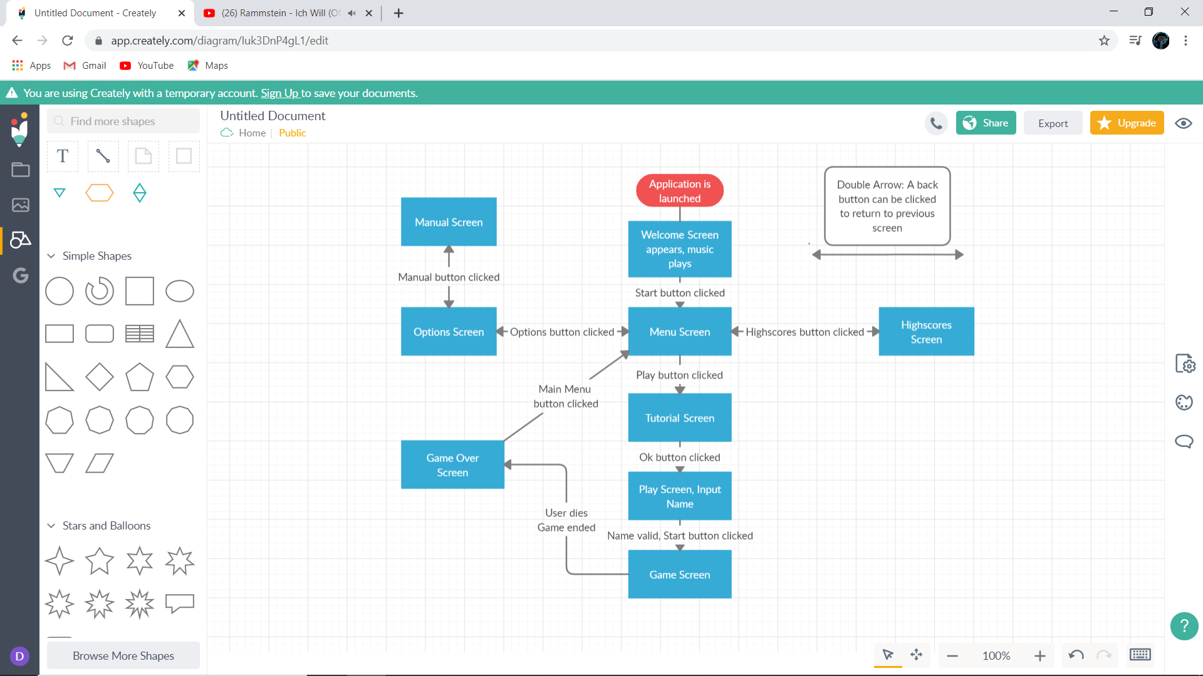Sequence of the basic application process. Shows how all screens are accessed and connected through buttons or actions.

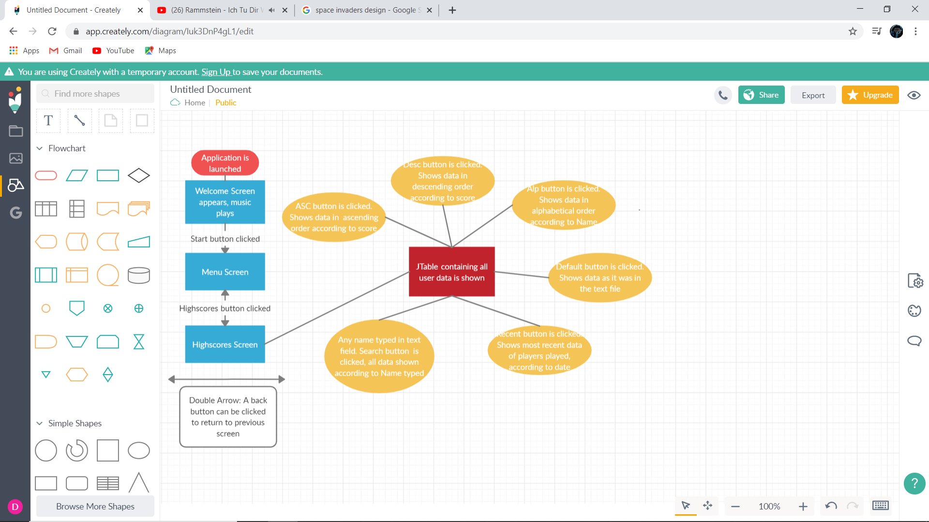Sequence of the “Highscore” screen and functionality of buttons.

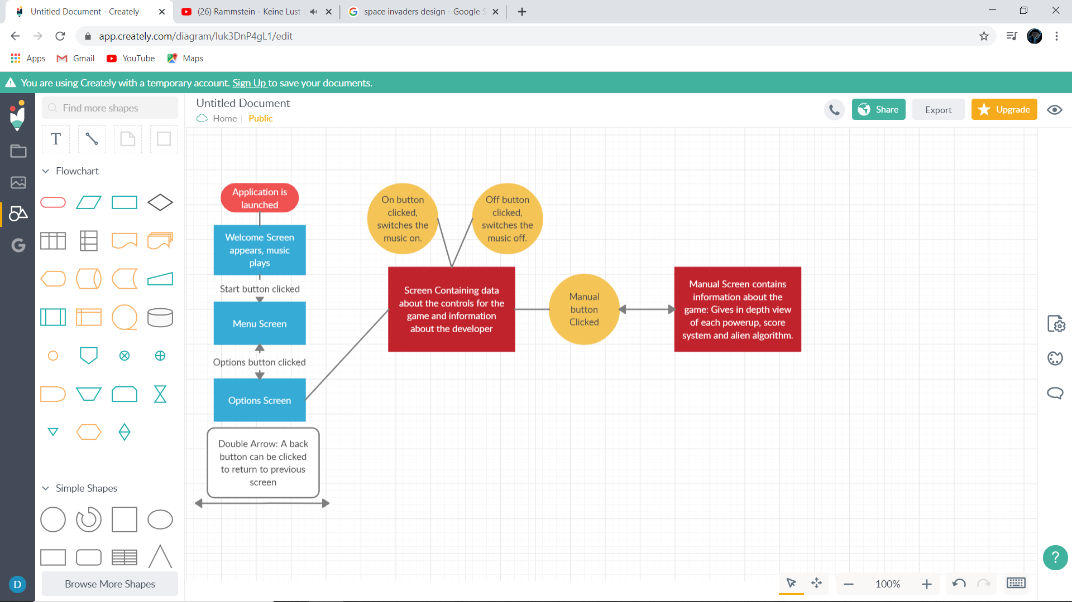Sequence of the Options and Manual Screens.

Sequence overview of the Tutorial, Play, Game and Game Over screens.

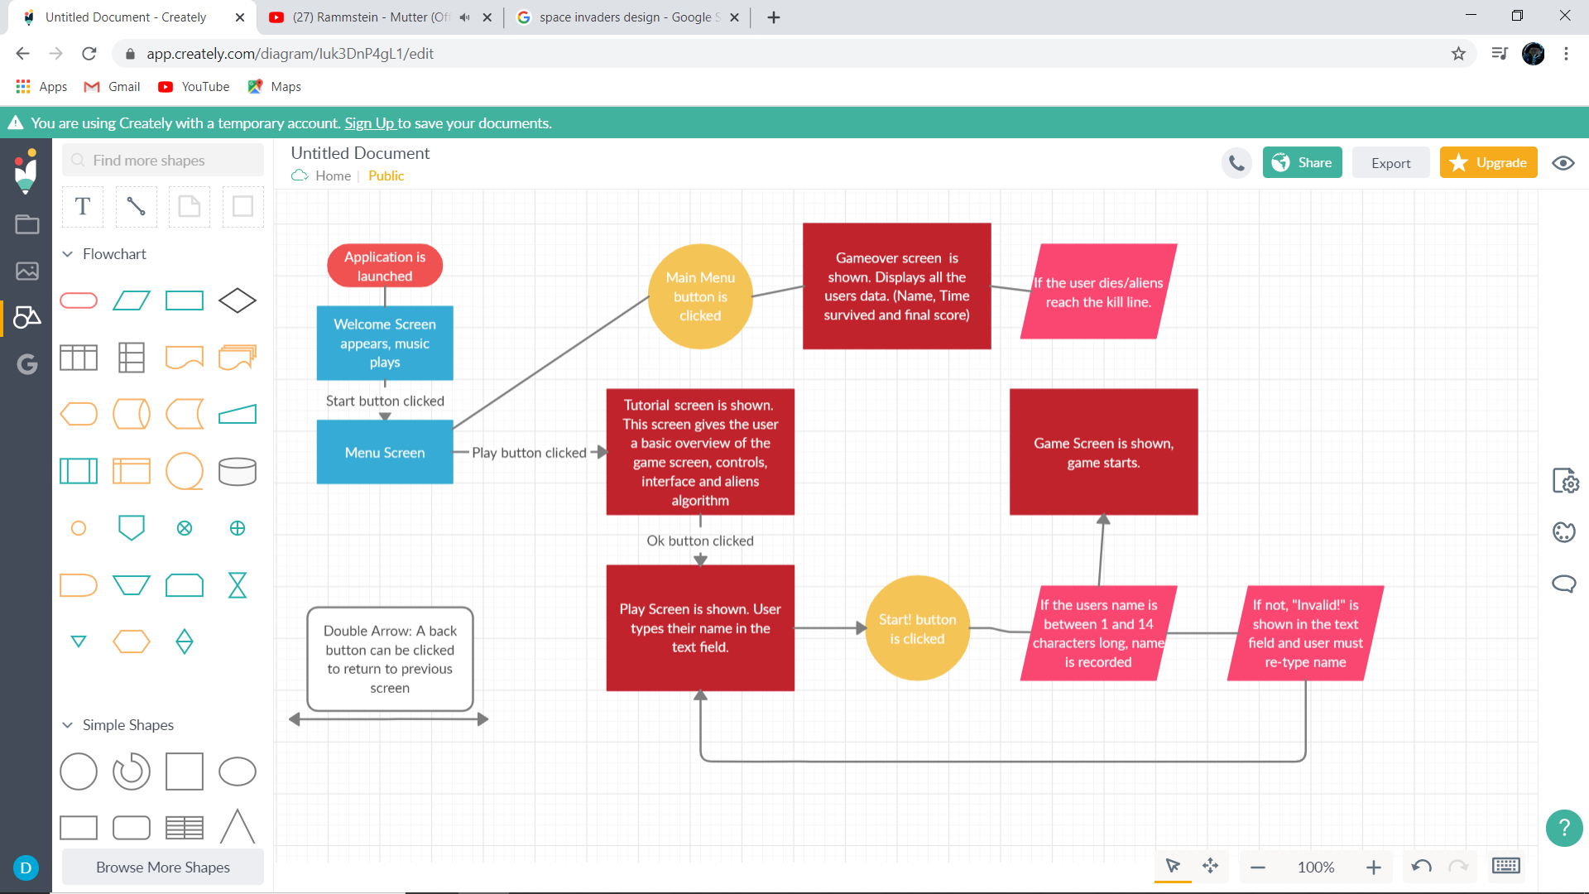

Sequence of the game screen and its functionality

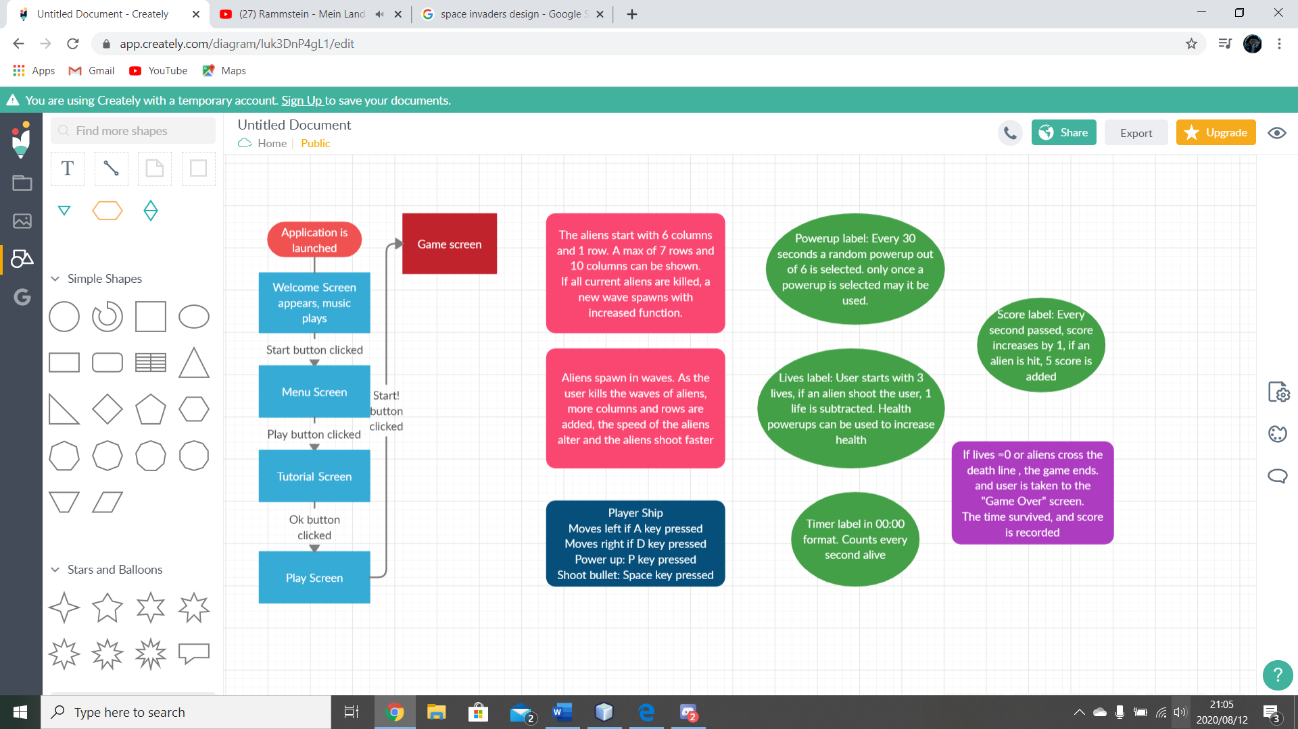

**Class design**

The following classes are used to create the functionality, visibility and user experience:

* “Sprite”
* “Player”
* “Alien”
* “Shot”
* “AlienBullet”
* “GameSA”
* “PlayerData”
* “DatabaseReader”
* “Music”

**The Sprite Class**

This class is used to create entities with basic movement, graphical and visibility properties. This class will be inherited by other classes based on the actions they perform. Each class that inherits from this method will not use all methods present.

|  |  |
| --- | --- |
| Fields: | Description: |
| + int x | x co-ordinate, used to set on graph axis |
| + int y | y co-ordinate, used to set on graph axis |
| - boolean dying | Used to define if an entity has died |
| - boolean visible | Used to set entity visible |
| - Image | Used to provide entity with image object |

|  |  |
| --- | --- |
| Methods: | Description: |
| + void setX(int x) | Used to set an entities x-coordinate |
| + void setY(int y) | Used to set an entities y-coordinate |
| + int getX() | Used to get the current value of the entities x-coordinate |
| + int getY() | Used to get the current value of the entities y-coordinate |
| + void die() | Sets visibility of the entity to false |
| +void setDying(boolean dying) | Sets the entities death |
| + isDying() | Returns the entities death status |
| + boolean isVisible() | Returns the visibility status of the entity |
| Protected void setVisible(boolean visible) | Sets the current entities visibility |
| + void setImage(Image image) | Sets an image object to an entity |
| + image getImage() | Returns the entities image object |

**The Player class**

This class will inherits from the sprite class and sets an image to the player entity which in this case is a spaceship.

|  |  |
| --- | --- |
| Fields: | Description: |
| Non used in this class | All fields from the Sprite class can be used |

|  |  |
| --- | --- |
| Methods: | Description: |
| Non used in this class | All methods from the Sprite class can be used |

|  |  |
| --- | --- |
| Constructor: | Description: |
| Public Player() | Sets an image object to the player class |

**The Alien Class**

This class will inherits from the sprite class and sets abstract x and y coordinates as well as image values to the class.

|  |  |
| --- | --- |
| Fields: | Description: |
| - AlienBullet AB | Each alien needs to be able to shoot, hence the use of the AlienBullet class is used |

|  |  |
| --- | --- |
| Methods: | Description: |
| + AlienBullet getAlienBullet() | Returns an AlienBullet object for the respective Alien |

|  |  |
| --- | --- |
| Constructor: | Description: |
| Public Alien(int x, int y, Image image) | The Alien constructor requires an alien to have an x, y and image value set |

**The Shot Class**

The Shot class will be used as a bullet object used by the Player (to shoot bullets). This class will inherit from the sprite class

|  |  |
| --- | --- |
| Fields: | Description: |
| Non used in this class | All fields from the Sprite class can be used |

|  |  |
| --- | --- |
| Methods: | Description: |
| Non used in this class | All methods from the Sprite class can be used |

|  |  |
| --- | --- |
| Constructor: | Description: |
| Public Shot(int x, int y) | X and Y coordinates needed  The constructor also sets an image object to the shot class |

**The AlienBullet Class**

This class will inherit from the Sprite class. This class will be used as an object for the Aliens class. An Alien object will contain a AlienBullet object (So that the aliens can shoot automatically)

|  |  |
| --- | --- |
| Fields: | Description: |
| - boolean destroyed | Contains the AlienBullets destroyed value |

|  |  |
| --- | --- |
| Methods: | Description: |
| Non used in this class | All methods from the Sprite class can be used |

|  |  |
| --- | --- |
| Constructor: | Description: |
| Public Player() | Sets an image object to the player class |

**The GameSA Class**

This class is where all functional, graphical and visual elements are implemented. This class contains all game logic. JFrames, TimerTasks, PaintComponents, PowerUps, Game Change etc. is implemented here.

|  |  |
| --- | --- |
| Fields: | Descriptions: |
| (java.swing)+Timer tm | Timer is used for the “ticks” of the game |
| + int count | Counter keeps track of when the timer ticks |
| +int x | Player ships x-coordinate |
| +int y | Player ships y-coordinate |
| +int velX | Player ships x movement velocity |
| +int velY | Player ships y movement velocity |
| +int Score | Keeps track of users score |
| +String Time | Keeps track of the timer (00:00) |
| +int Lives | User has 3 Lives |
| + int HighScore | Gets users final score |
| +String FullTime | Gets users final Time (00:00) |
| + boolean gameEnd | Boolean that can end game |
| (Java.util)+Timer timer | Timer for “String Time (00:00)” |
| + int i | Keeps track of timer ticks |
| + String imgArr[] | Array of file paths that provide rows of aliens with different images |
| + int alienCount | Counter for all current aliens |
| + int direction | Sets x-coordinate direction (left or right) of aliens |
| + int down | Sets y-coordinate of aliens |
| + int addRows | Tracks current and future rows of aliens |
| + int addColumns | Tracks current and future of col of aliens |
| + int change | Tracks the waves of aliens |
| + int speedChange | Gives current/future speed to aliens |
| + int alienBulletspeedChange | Current/future of alien bullet speed |
| - List <Alien>aliens | An array list of Alien objects |
| - Shot shot(0-4) | Shot objects initialised |
| - Player | Player object initialised |
| + boolean PowerUP | Tracks if Powerups are initialised |
| +boolean usePowerUp | Tracks if powerups are used |
| + String PU | Shows current powerup |
| + int SpeedPowerUp | Player speed powerup multiplier |
| + int BulletVelPowerUp | Player bullet speed multiplier |
| + boolean ClearWavePowerUp | Player clears alien wave powerup |
| + int num | Stores random variable that picks powerup |
| + int immuneTime | Time that player is immune powerup |
| + int current health | Stores current health before the use of a powerup |
| + boolean AddBullet | Powerup that fire 5 bullets at once |
| + int AddBulletTime | Amount of time that the addbullet powerup can be used for |
| + JFrame jf | Creates Jframe object |

|  |  |
| --- | --- |
| Methods: | Description: |
| - void drawPlayer(Graphics g) | Draws the player object, sets x and y |
| - void drawAliens(Graphics g) | Draws the alien objects, sets x and y |
| - void drawShot(Graphics g) | Draws the shot object, sets x and y |
| - void drawAlienShot(Graphics g) | Draws the AlienBullet object |
| + void paintComponent(Graphics g) | Draws all on screen graphics, above objects |
| + void actionPerformed(ActionEvent e) | Called whenever the timer ticks, this method repaints all graphics components every 40 milliseconds to appear as movement |
| + void Shoot() | Allows the user to shoot if a condition is met |
| + void ShootAlienDetection() | Detects collision between the Shot and Alien objects, if the shot collides etc. |
| + void MoveShip() | Allows the users Player object to be moved if a condition is met |
| + void AlienmovementPattern() | Moves the current wave of aliens left, right and down based on conditions met |
| + void AlienShipDetection() | Detects if the aliens and ship collides |
| + void GameChange() | Method that makes the game progressively harder, after each wave cleared by the user, alien rows, columns, speed, bullet speed increases |
| + void AlienShootandDetection() | Method that allows the aliens to shoot back at the user randomly as well as detect if those bullets hit the users ship |
| + void PowerUp() | Allows the user to be stronger in the game as it progresses, allows user to receive a random powerup at set intervals |
| + void GameOver() | Tests if the game is over, ends timer, stores PlayerData values and changes screens |
| + void KeyPressed(KeyEvent e) | Detects key presses by the user, is used to allow the user to play the game |
| + void KeyReleased(KeyEvent e) | Detects if a key is no longer pressed, resets values. |
| + void runTimer() | Runs the java.util Timer that displays time (00:00) |
| Static String getTime(int i) | Converts int i into a String in the format of 00:00 |

**The PlayerData Class**

This class stores 4 values for each individual player (Name, Time, Score, Date).

|  |  |
| --- | --- |
| Fields: | Descriptions: |
| - String Name | Stores the users name |
| - String Time | Stores the users time survived |
| - int Score | Stores the users final score |
| - String Date | Stores the date that the users played |

|  |  |
| --- | --- |
| Methods: | Descriptions: |
| + String getName() | Returns the player name |
| + String getTime() | Returns the players time |
| + int getScore() | Returns the players score |
| + String getDate() | Returns the date the player played on |
| + String toString() | Returns a String that displays all the users data in one line |

**The DatabaseReader Class (DatabaseWriter Method)**

This class reads all user data from a text field database called “DatabaseSA”. The DatabaseWriter method writes the data from one individual player into the database after the user has ended the game. The Database writer method occurs in the gui/jframe class called “GameOver”.

|  |  |
| --- | --- |
| Fields: | Descriptions: |
| - PlayerData player[] | An array of PlayerData objects |
| - int Pcount | Counter for the amount of players |
| + Scanner scan | Scanner to scan the data from the database |

|  |  |
| --- | --- |
| Fields: | Descriptions: |
| + String Show() | Returns all data in the database as it was written |
| + String Descending() | Returns all data in descending order based on score |
| + String Ascending() | Returns all data in ascending order based on score |
| + String Search(String name) | Returns all data based on if the parameter is equal to the names in the database |
| + String Alphabetical() | Returns all data in alphabetical order based on name |
| + String Recent() | Returns all data in order based on the recent players of the game |

**The Music Class**

This class allows for music to be played and be turned on or off based on user command. The music played is a collection of 5 songs (DangerZone, Shoot to Thrill, We didn’t start the fire, Perbutrator, Money for nothing).

|  |  |
| --- | --- |
| Fields: | Descriptions: |
| - static String music | Stores the filepath of the music file |
| + static Clip | Used to play execute the audio file |
| + String songFile | Gets the filepath |
| + File MusicFile | Creates an instance of an audio file |

|  |  |
| --- | --- |
| Fields: | Descriptions: |
| - static void playMusic | Plays the music |
| + static String getSong() | Returns an audio file path |
| + static void Stop() | Stops the music |
| + static void Start() | Starts the music |

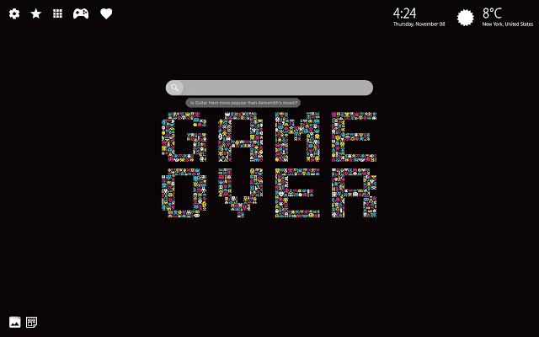All other classes in the Space Attack program that were not mentioned are used for the GUI creation/quality of life for the user.

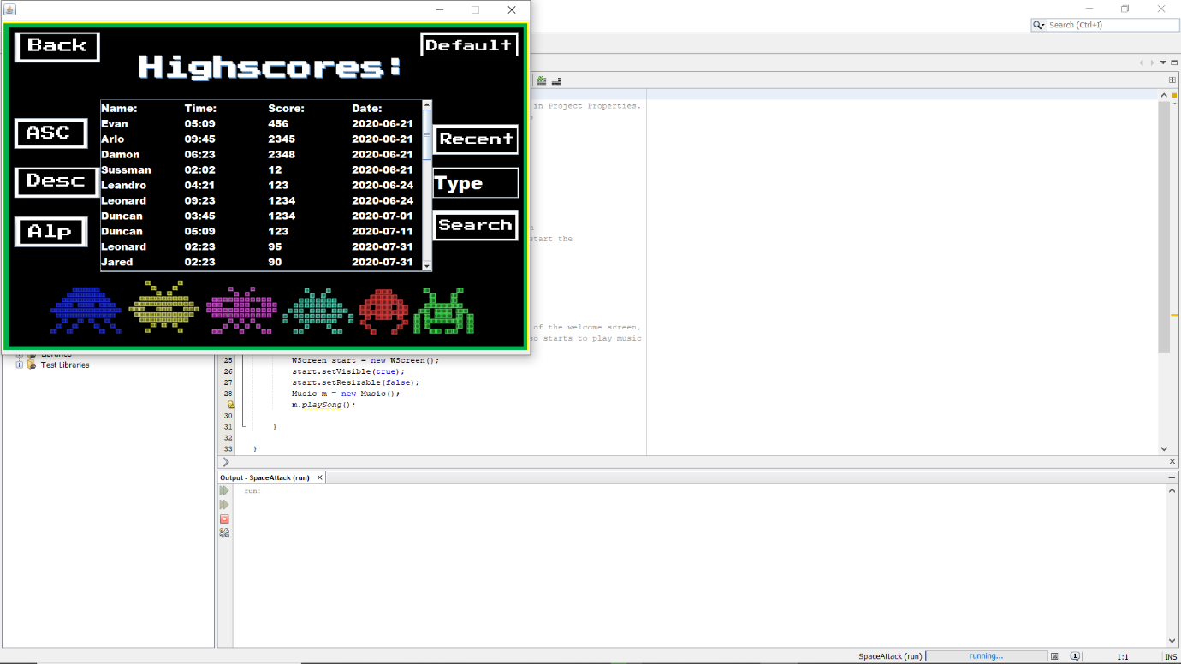**Persistent storage design**

The following components have been used and stored:

* Text File database
* Audio File
* Graphical images components

Example of how the text file data is read into the SA program

**Text File Database**

The Text File database layout and information The Properties of the Database

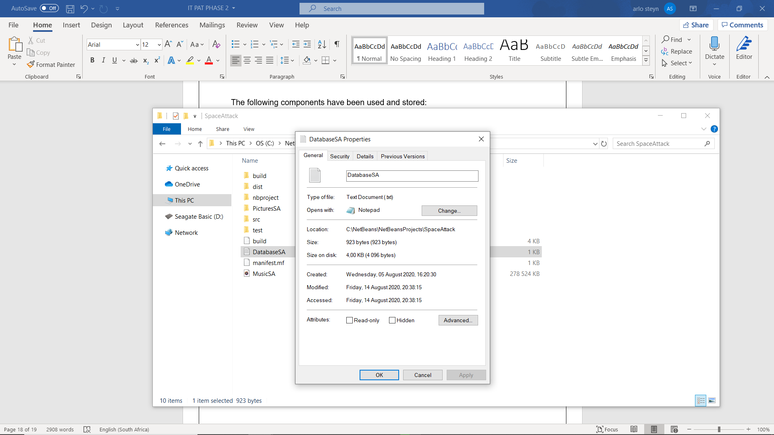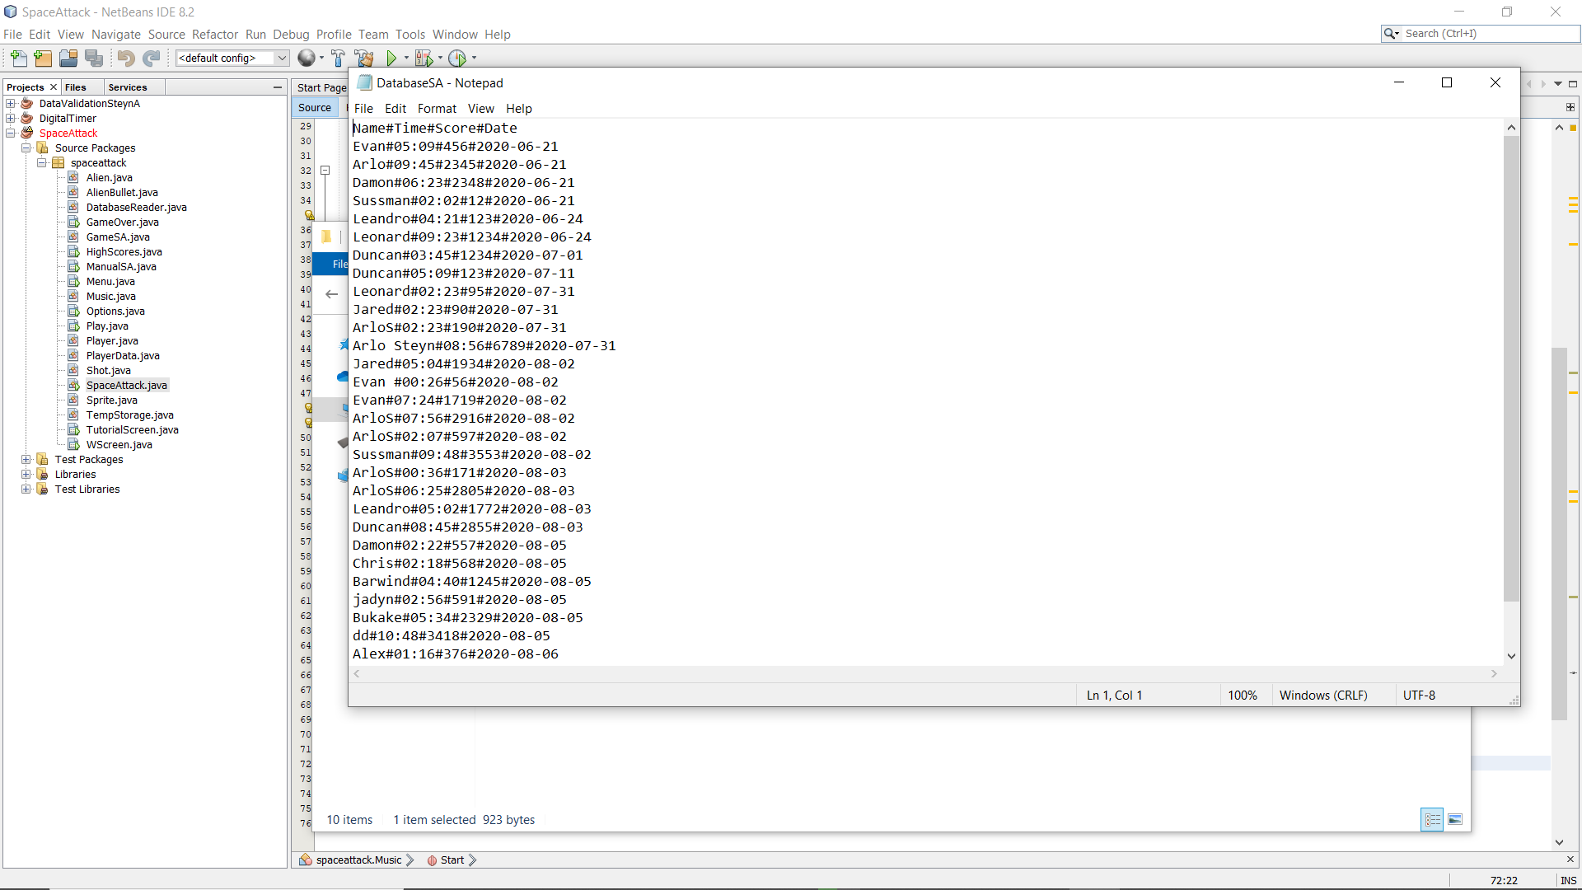

The Text file database (“DatabaseSA”) will be used by the application to read and write user data. Data such as the users name (String), time survived (String), score (int) and date played (String) will be stored.

The method “DatabaseWriter” will be used to write the data into the database. This method will use “#” to separate the various data from one another. One line of data in the database contains one user value of information.

**Audio File Storage**

The Space Attack program plays music form an audio file. This audio file is used in Java and converted to an executable file. The file is in “.wav” form.

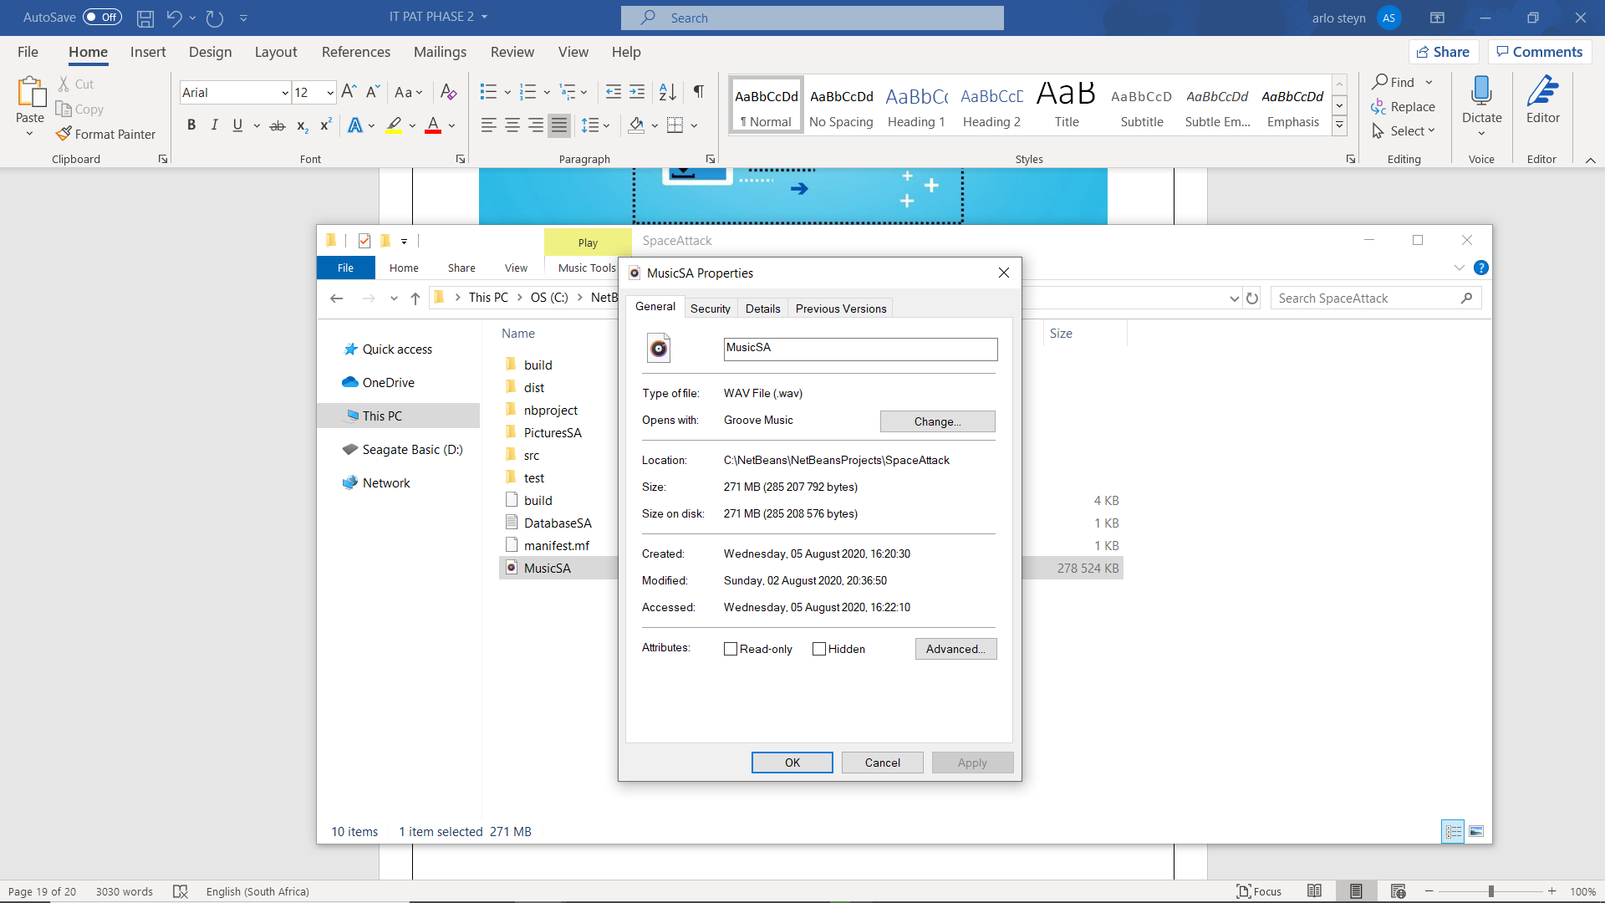The audio file is called “MusicSA”, below are the properties of the file.

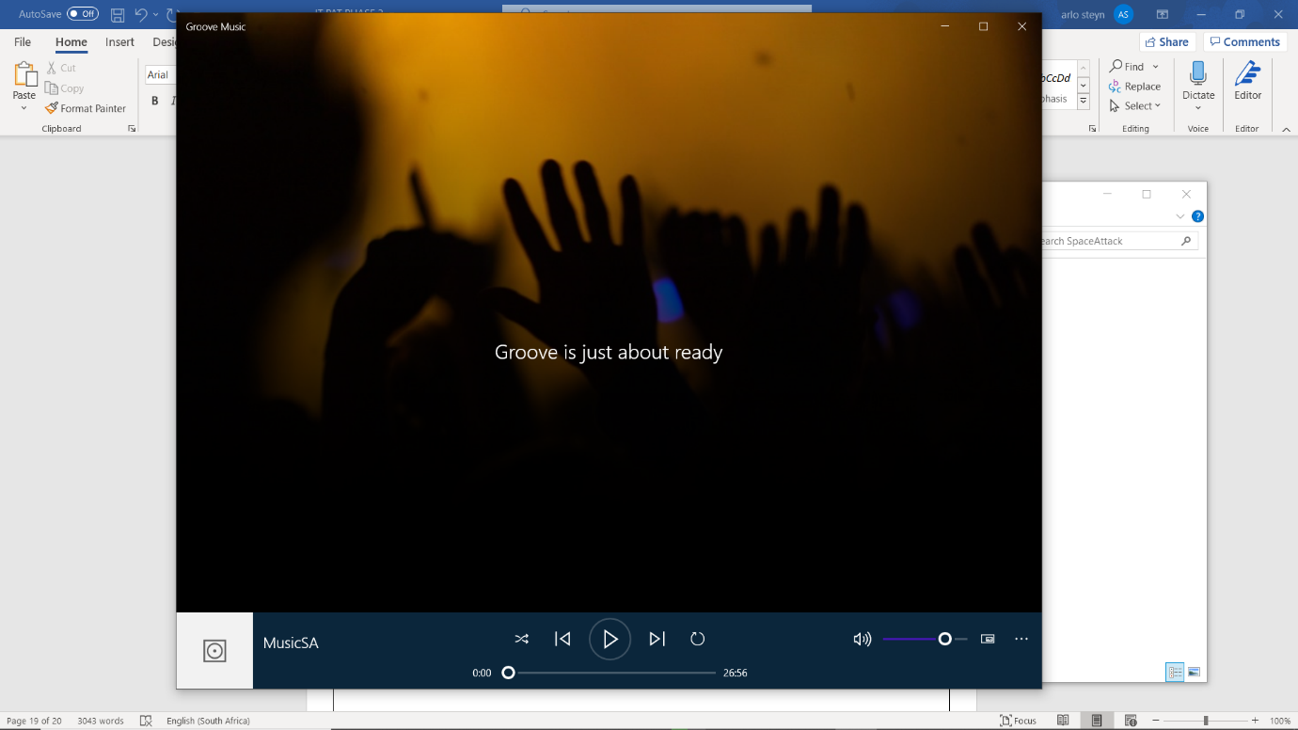The file playing outside of the program.

The audio file is 26 minutes :56 seconds long. The following music files were downloaded, converted from an mp3 file to a wav file (with the use of Audacity) and put together (using audacity) to form “MusicSA”:

* Danger Zone – Kenny Loggins.
* Shoot to Thrill – ACDC.
* We didn’t start the fire – Billy Joel.
* Perturbator – Future Club.
* Money for Nothing – Dire Straits.

**Graphical images/GUI design**

GUI components of the Space Attack program were designed in Microsoft word, paint 3D and downloaded pictures from the internet.

This is the properties of the file that stores all the GUI/Images used in the SA program.

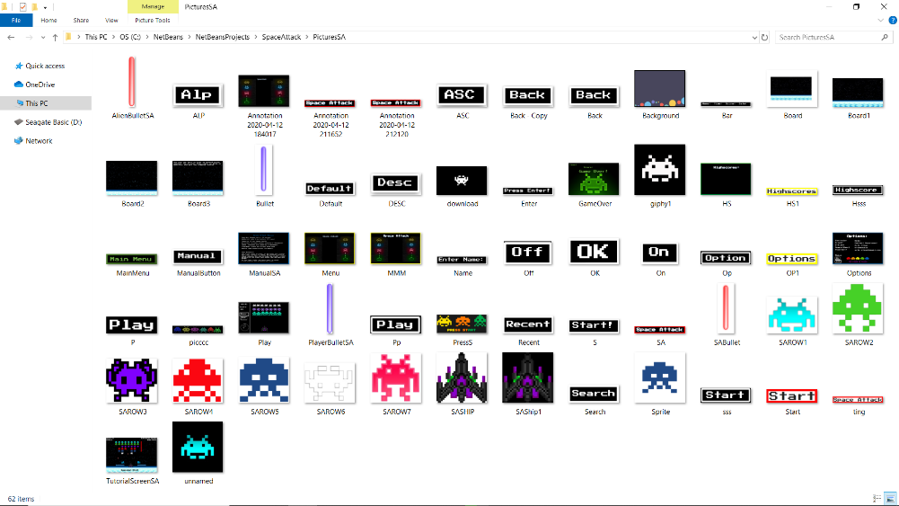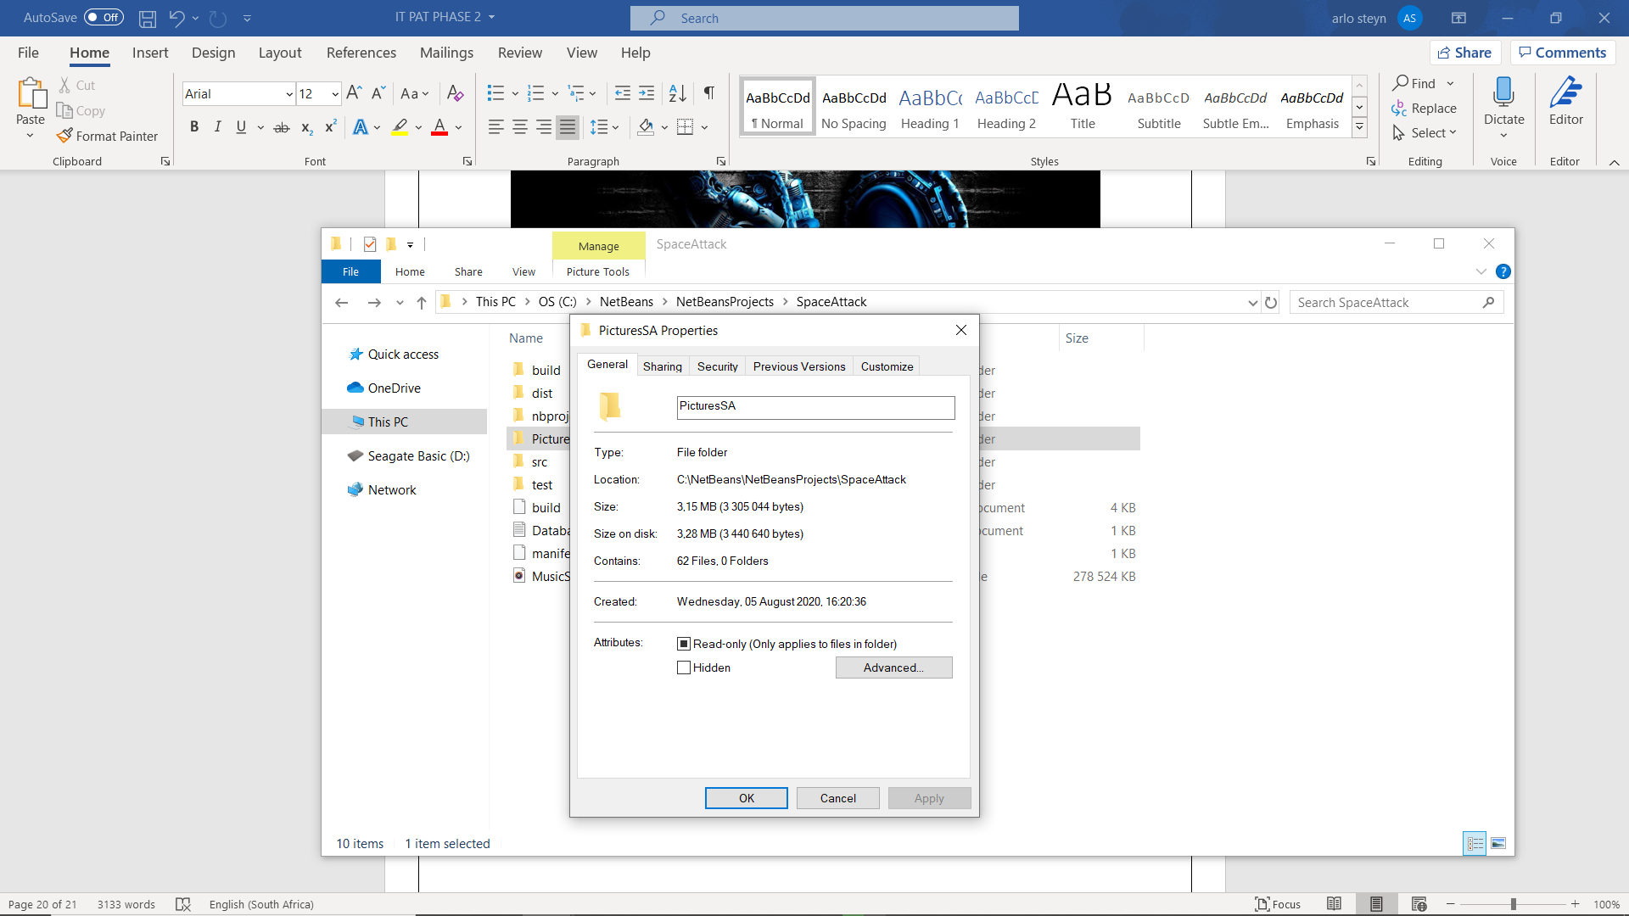

The above files are stored in PNG or JPG file formats.

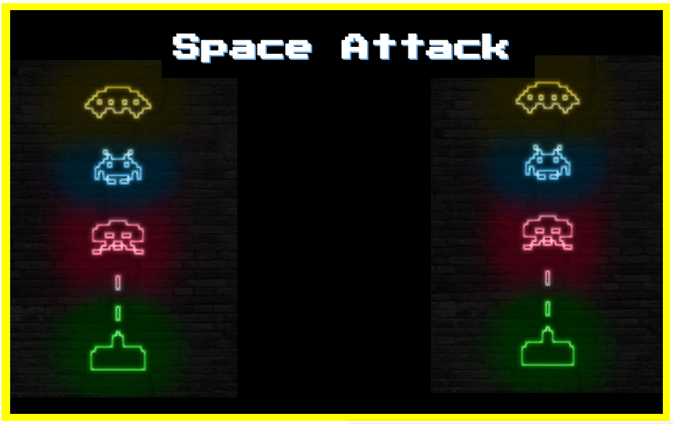Example of GUI component designed in Microsoft word or paint 3D: (Menu Screen + OK button)



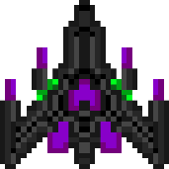Examples of images downloaded from the internet:

**Explanation of storage design**

The Space Attack game/program was purposely designed to have a retro gaming feel and look. The music files picked and stored are appropriate for the theme. The design of the GUI as well as pictures were also designed and chosen to fit the appropriate theme. The text file database was chosen for its simplicity in terms of writing and reading from the database. All data is locally stored in the application documents. This is to allow the ease of implementing the program on multiple devices however the database data will remain constant depending on the computing device running it. Space Attack was designed to run on an arcade machine where multiple people would play, making the database accessible to anyone who plays it. If the program is run on an individual’s device, only he/she will be able to play, meaning that only he/she will be able to fill up the database with data.

The audio file is in a .wav format, this is due to the reduced size and ability to alter/change the music files chosen.

The Pictures/GUI components are stored in the application files in PNG/JPG files, this is due to the reduced size in data used and simplicity in use and interpretation in the program.

The text File database (.txt) was chosen due to the reduced storage that is needed to store the data. This database is also used in all computing devices as well as simpler to code than other databases such as access.

